**Note: Please don't edit this doc**

**Question 1: YOU HAVE ALREADY DONE THIS QUESTION**

Note:

1. This question is lengthy.
2. Don’t panic and just give your best.
3. Spend 1 hour first to understand the requirements.

Introduction

The assignment is designed for all students to get experience with building a complex system

from the ground up, using the core concepts of Object-Oriented Programming (OOP) as well as

all the Python programming tools at their disposal.

**Important files for this lab: (files are in the folder)**

1. *indexer_student.py*: **You will need to modify this file (and this file only)**
   1. You need to implement the following functions in this file
      1. **add_msg**
      2. **indexing**
      3. **search**
2. *AllSonnets.txt:* A small collection of Shakespeare's sonnets
3. roman2num. py: A Python module for converting integers to roman numerals
4. roman.txt.pk: A binary file which contains a roman number integer mappings
5. p1.txt: the first sonnet, just for testing purposes

**You will implement functions for the class Index**.

**Hint**: We will explain the requirements for each of them on the following pages.

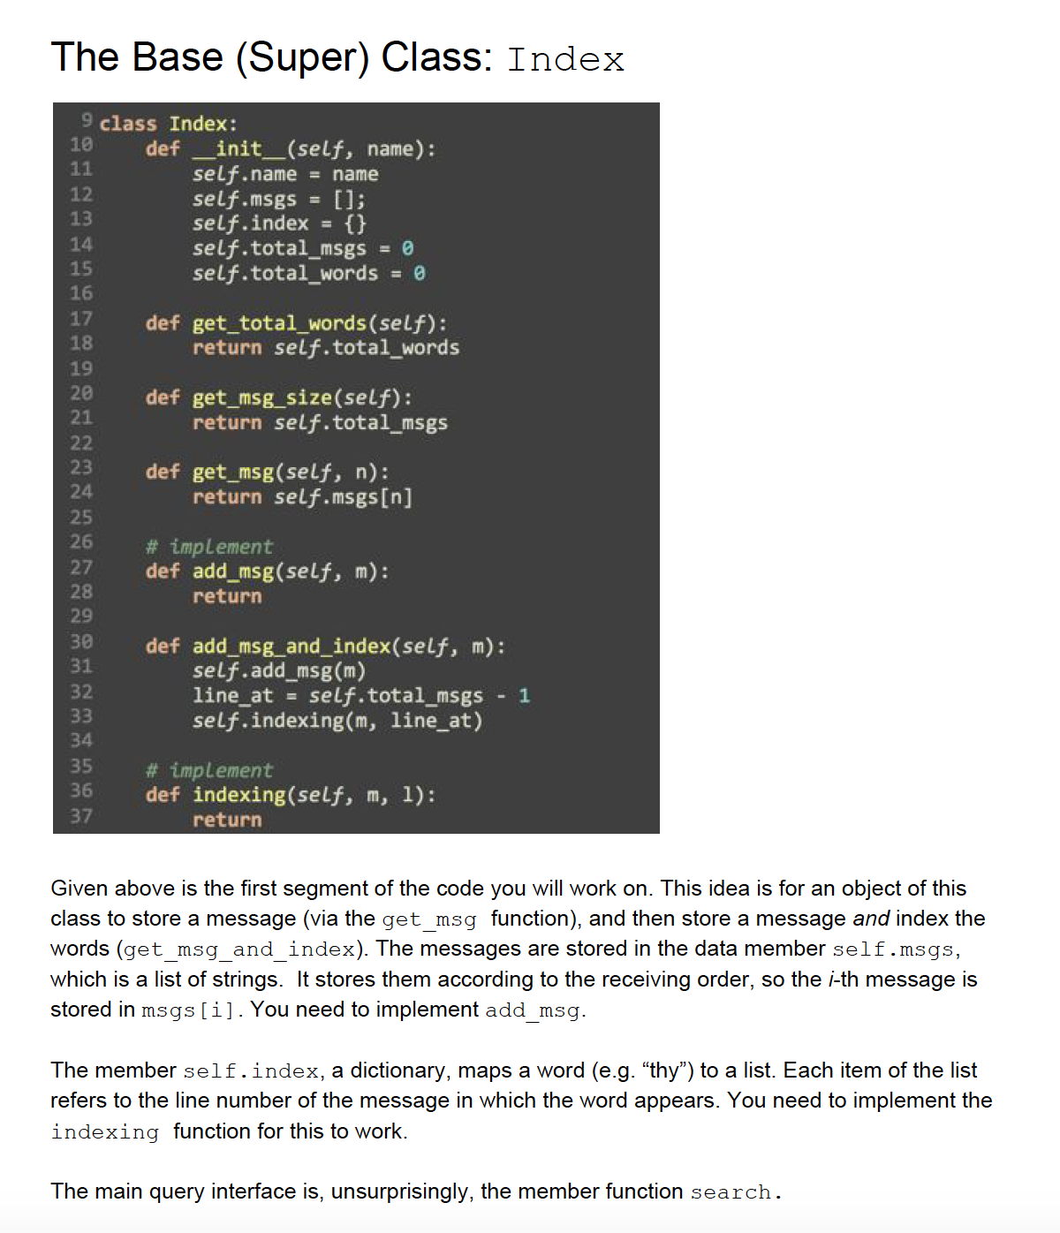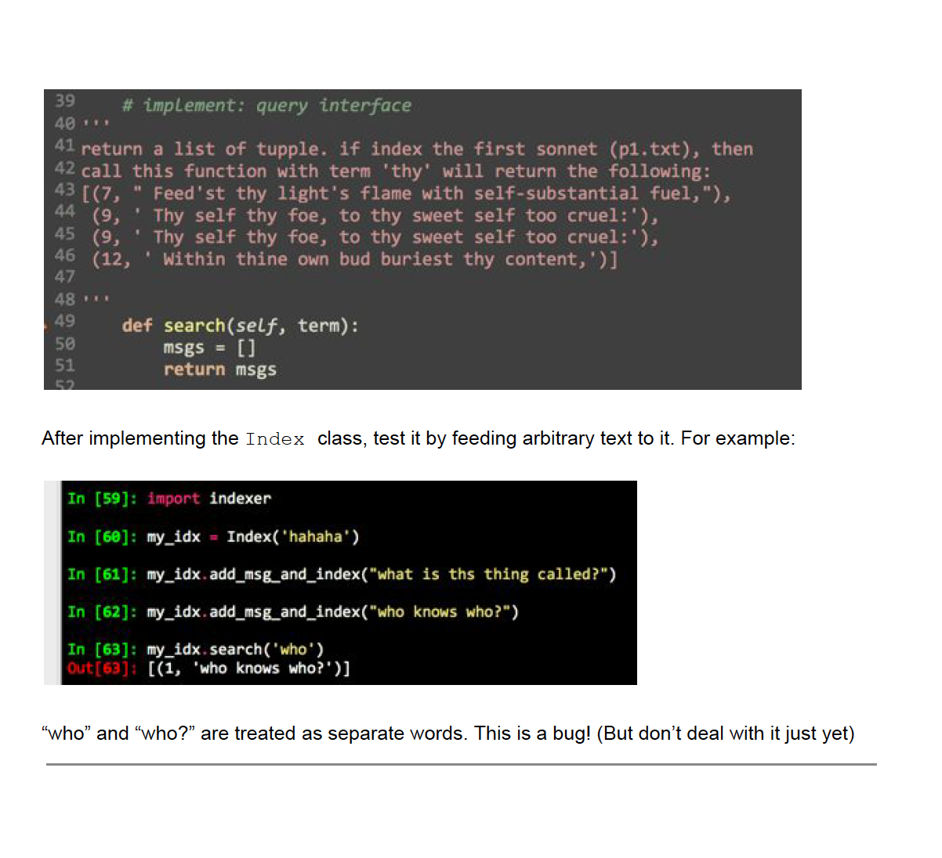

**Question 2: The Derived (Sub) Class: PIndex**

**Note:** To open Console, type **python** in the terminal.

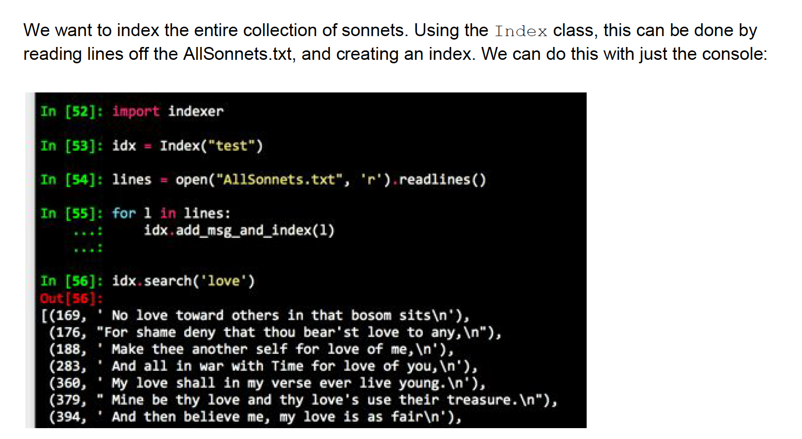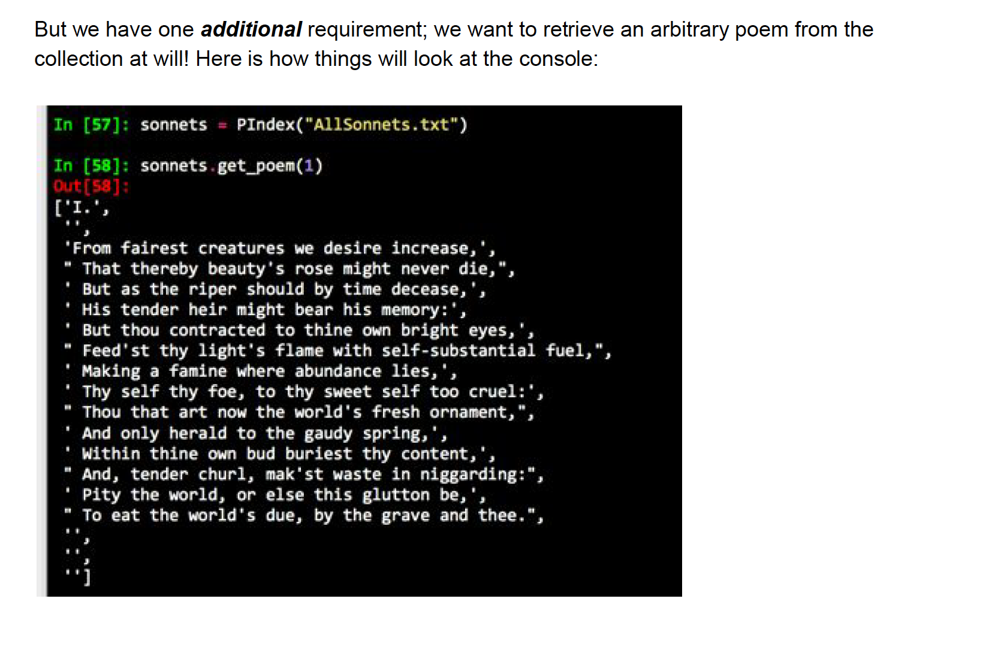

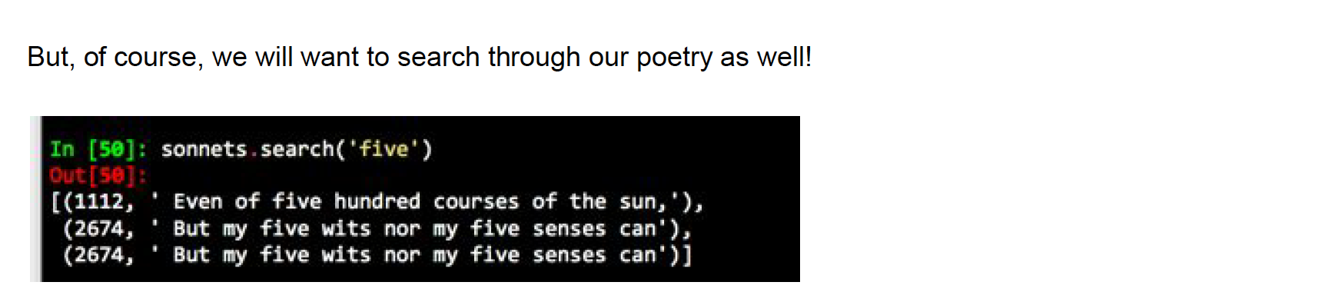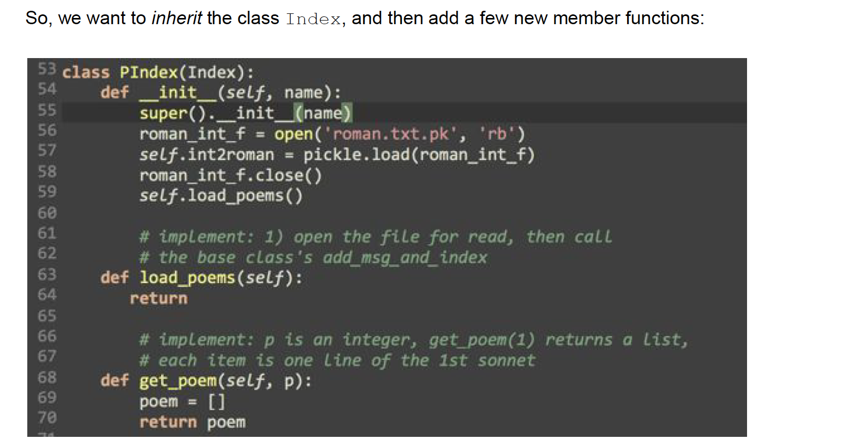

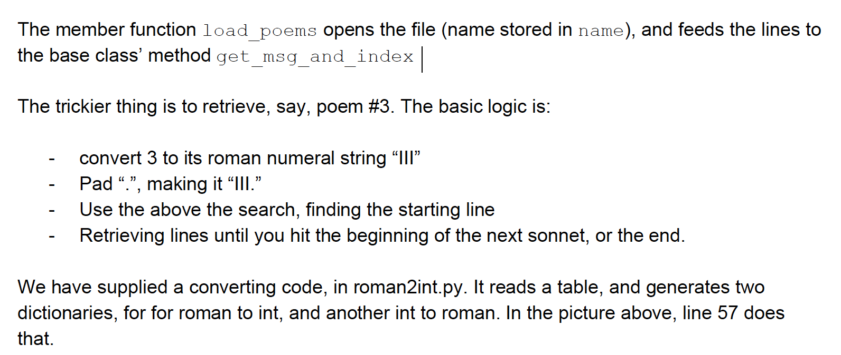

**SUMMARY**

